**PRACTICAL 3**

|  |  |  |  |  |  |
| --- | --- | --- | --- | --- | --- |
| **Name:** | Harsh Shah | **Semester:** | VII | **Division:** | 6 |
| **Roll No.:** | 21BCP359 | **Date:** | 06-08-24 | **Batch:** | G11 |
| **Aim:** | Understanding Pre-Processing in Datasets. | | | | |

**Question 1**

**Dataset:** diabetes.csv

import numpy as np

import pandas as pd

from sklearn.preprocessing import MinMaxScaler, Binarizer, StandardScaler

df = pd.read_csv('diabetes.csv')

***# Dataset without label/class***

df1 = df.drop(['Outcome'], *axis*=1)

***# Scaling***

min_max_scaler = MinMaxScaler(*feature_range*=(0,1))

scaled_features = min_max_scaler.fit_transform(df1)

scaled_df = pd.DataFrame(scaled_features, *columns*=df1.columns)

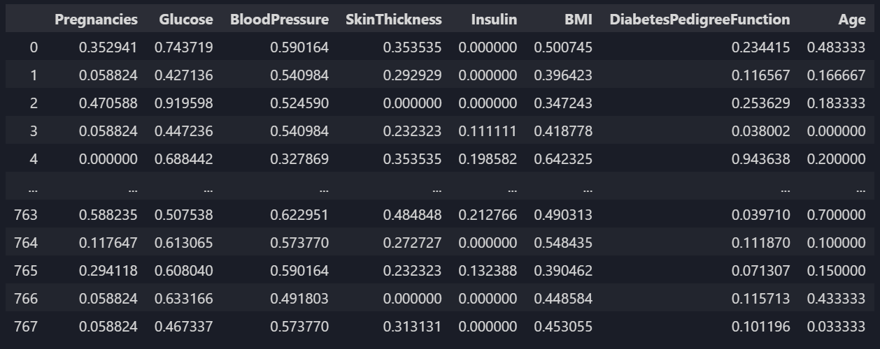

Figure 1: Scaled df

***# Binarization***

binarizer = Binarizer(*threshold*=0.0)

binarized_data = binarizer.fit_transform(scaled_df)

binarized_df = pd.DataFrame(binarized_data, *columns*=scaled_df.columns)

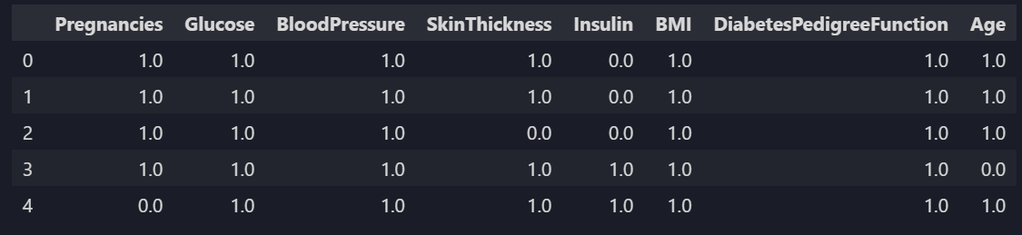

Figure 2: Binarized df.head()

***# Standardization***

scaler = StandardScaler()

standardized_data = scaler.fit_transform(binarized_df)

standardized_df = pd.DataFrame(standardized_data, *columns*=binarized_df.columns)

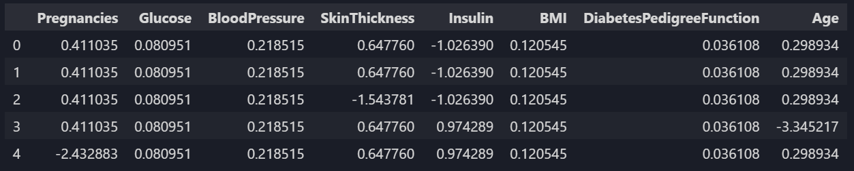

Figure 3: Standardized df.head()

**Question 2**

**Dataset:** spam.csv

import re

import nltk

import pandas as pd

from nltk.corpus import stopwords

nltk.download("stopwords")

df = pd.read_csv("spam.csv", *encoding*="latin-1")



Figure 4: df.head()

**# *Remove Puntuation and Stopwords***

*def* remove_punctuations(*text*):

    return re.sub(*r*"[^\w\s]", "", text)

*def* remove_stopwords(*text*):

    stop_words = *set*(stopwords.words("english"))

    return " ".join([word for word in text.split() if word.lower() not in stop_words])

df["v2"] = df["v2"].apply(remove_punctuations)

df["v2"] = df["v2"].apply(remove_stopwords)



Figure 5: df.head()